Bio Questionnaire
TTPO Website
We are enhancing the TTPO website (www.ttpo-wa.org) and we would like to add your information to the site. To do so, we will need some brief information from you along with a recent photo (photos are optional but if you do submit one, any photo will do, I can crop and adjust the photo as needed prior to posting/publishing). If you want your information listed on the website please take a few minutes and fill out the questionnaire.
Example of How the Data will be used
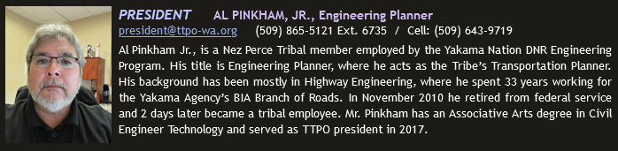
If you are a TTPO Officer, Board Member, or Tribal Planner:
Seal/logo
Note for TTPO Officers and Tribal Planners: We would like to include the tribal seal or logo used for your tribe and place them next to your name as a tribal representative. To do so please email me your graphic.*Again, please get permission to use the graphic on the TTPO website if you want it to appear.

If you are a WSDOT Employee (Megan, maybe you can provide me a directory of who should be listed):

Other Regional Planners, Consultants, etc. who attend and contribute to the TTPO:
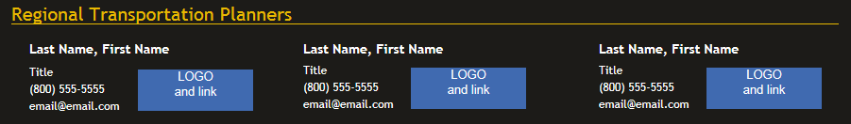

AGAIN, THE TTPO WEBSITE IS BEING DESIGNED AS A RESOURCE FOR COORDINATION, COLLABORATION, CONSULTATION, AND COMMUNICATION FOR TIBAL PLANNERS IN WASHINGTON STATE. WE APPREIATE YOUR ASSISTANCE IN BUILDING THIS TOOL!

Please fill out the applicable questions based on your role with TTPO as described above. When complete, please scan this form back to chrisrobideau@gmail.com for addition to the TTPO website.
Last Name: | First Name: |  |  | Middle Initial:
Email Address: | Phone Number: |  | Title:
Tribe/Agency/Company/etc. |  | Website Address
# of Years in Tribal Planning? |  | # of Years in Tribal Planning in Washington State?
As a planner, what do you feel your specialties are within the tribal planning arena that you feel other members may be able to benefit from? (please circle all that apply and place an * next to you three strongest)
TTP Program Transit Safety Maintenance

Const. Mgmt. Utilities Engineering Education

638 Contracting BIA “G2G” FHWA “PA” Direct Service

Safe Routes to School TIGER Grant Housing Health Services

Economic Dev. Emerg. Response 911/Addressing ERFO

Trans. Planning Land Use Pl. Strategic Pl. Traffic Modeling

Environmental ROW Cultural Pres. Land Development

Pedestrian TP Bicycle TP Freight Rail

GIS Asset Mgmt. Hydrology Wetlands

Biological Survey Geotechnical Grant Writing
Please enter other:
Please sign below authorizing use of the images provided.

______________________________ (sign)
_________________
(date)
A photo of myself has been provided? YES NO
A tribal seal or logo has been provided? YES NO

